**Branching and Merging**

1. Installed p4merge from perforce.com
2. Configured both diff and merge tool using git bash

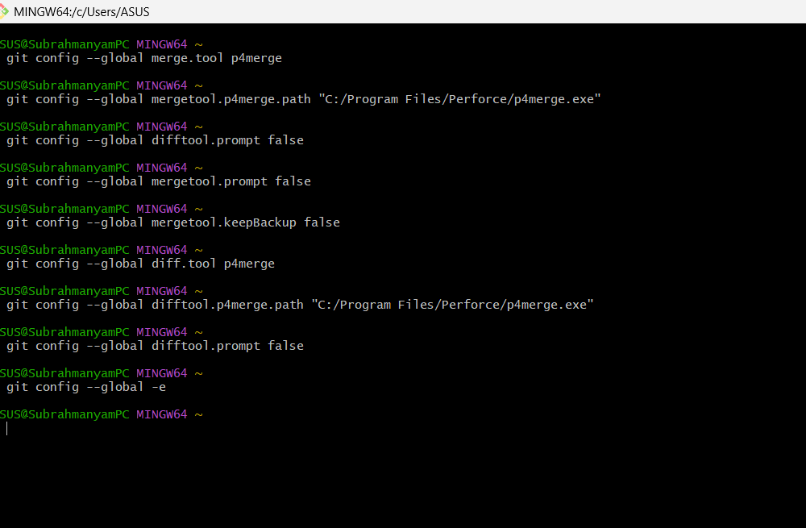

**Verifying the configuration:**

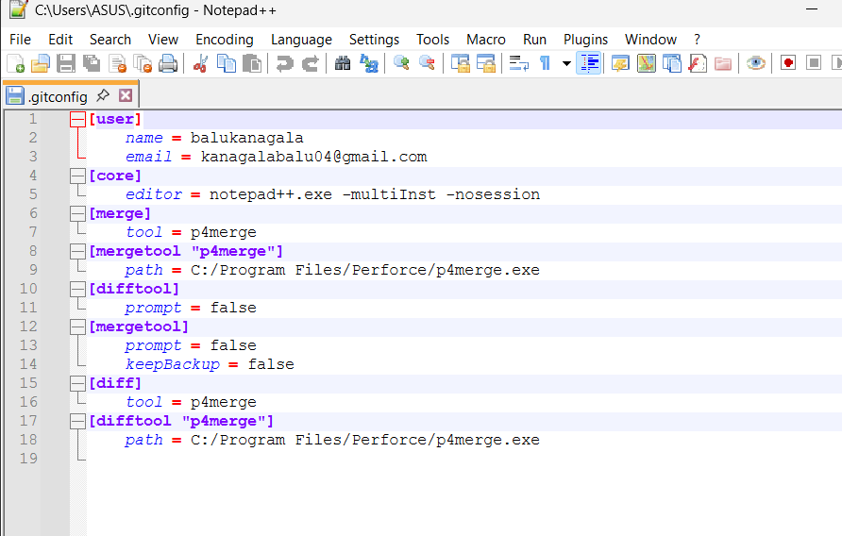

**Branching**

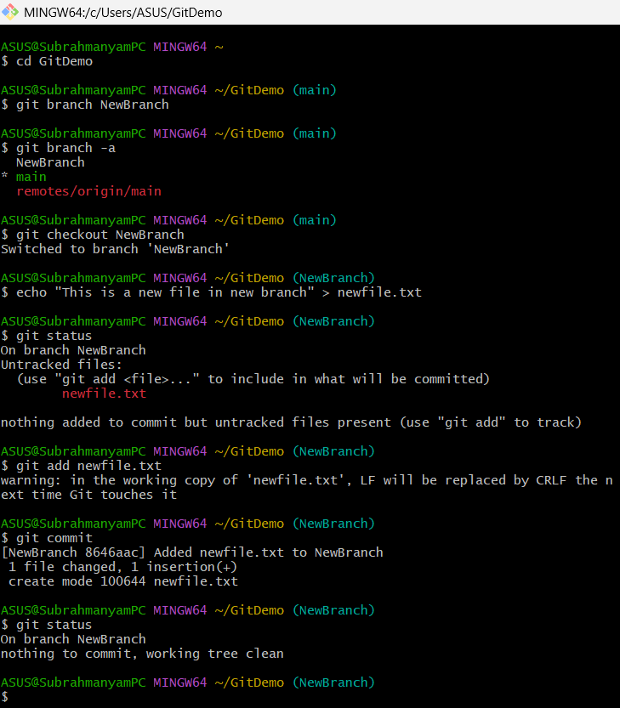

Commit message in notepad++

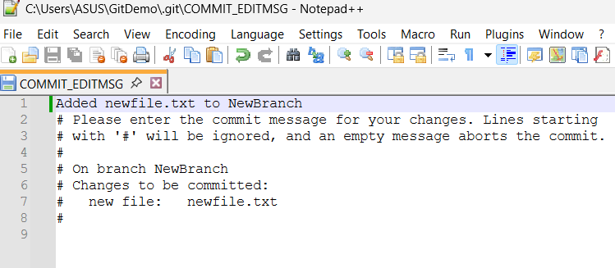

NEXT PAGE

**Merging and deleting new branch and pushing results to main**

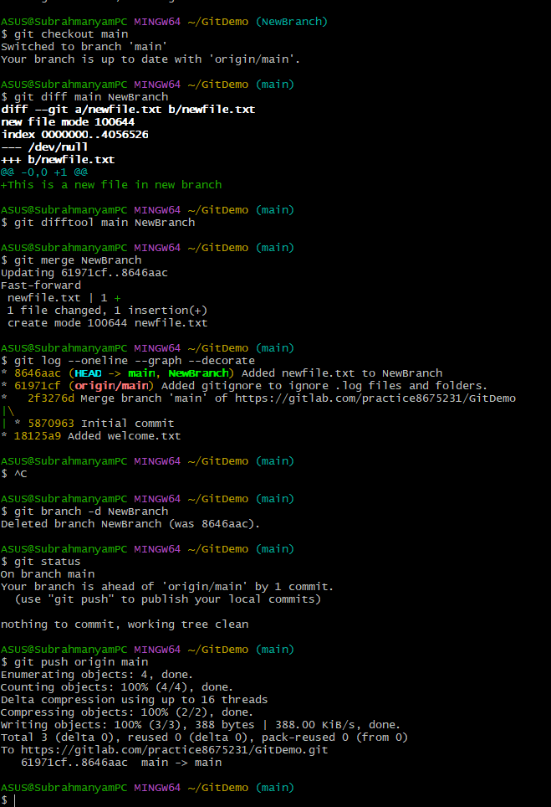

**Diff tool output**

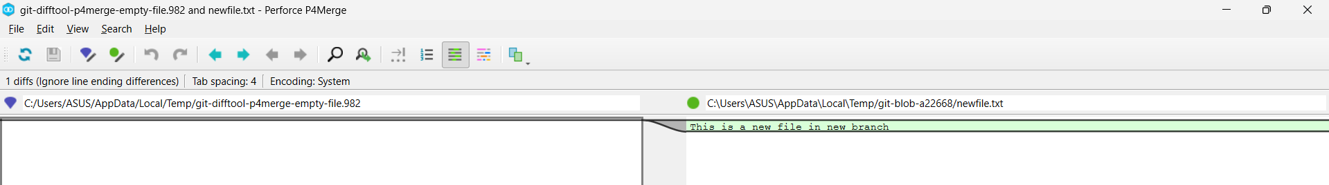

Gitlab Verification

* + NewBranch is merged to main.
  + NewBranch deleted

